**Unity**

**Maverick**

**Package**

**User Guide**

Release 0.1

*Copyright (C) 2025 Ameria AG - All Rights Reserved*

**Overview**

We use Unity version 2021.3.33 or later

**What do you need to use maverick package**

1. Install packages via NuGet (if not installed yet)  
<https://github.com/GlitchEnzo/NuGetForUnity/releases>

*Newtonsoft.Json (9.0.1)*

2. Import Unity-MaverickPackage_v.0.1 unity package

3. Restart unity editor

**Prepare to build maverick package**

1. Configure package data scriptable object:

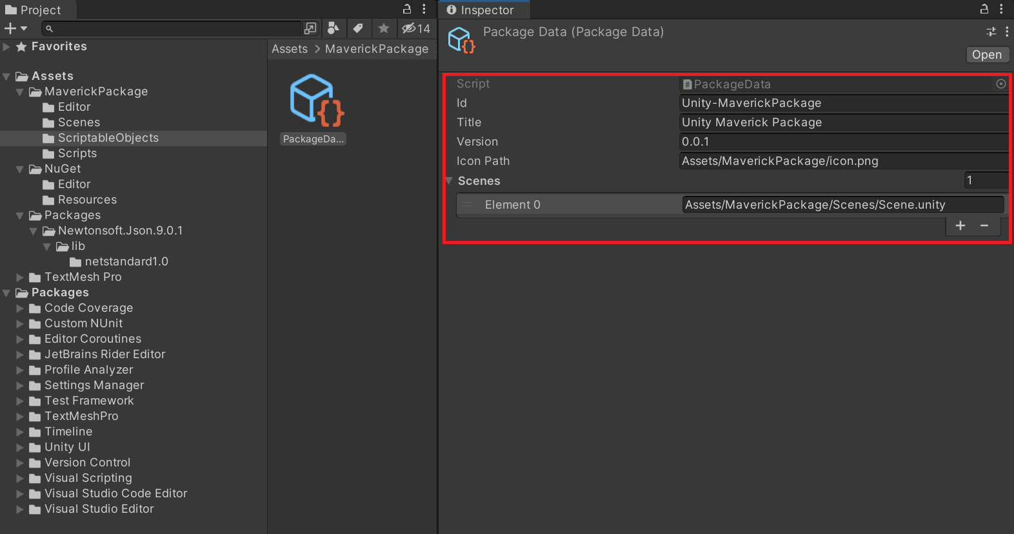

According to our developers conventions:

- each unity application should have prefix “Unity-“ in Id param

- versioning must have three digits in standard format x.y.z

- icon should have 512x512px 72 dpi or higher in png format

Also, you need to add all scenes in same order like in build settings:  
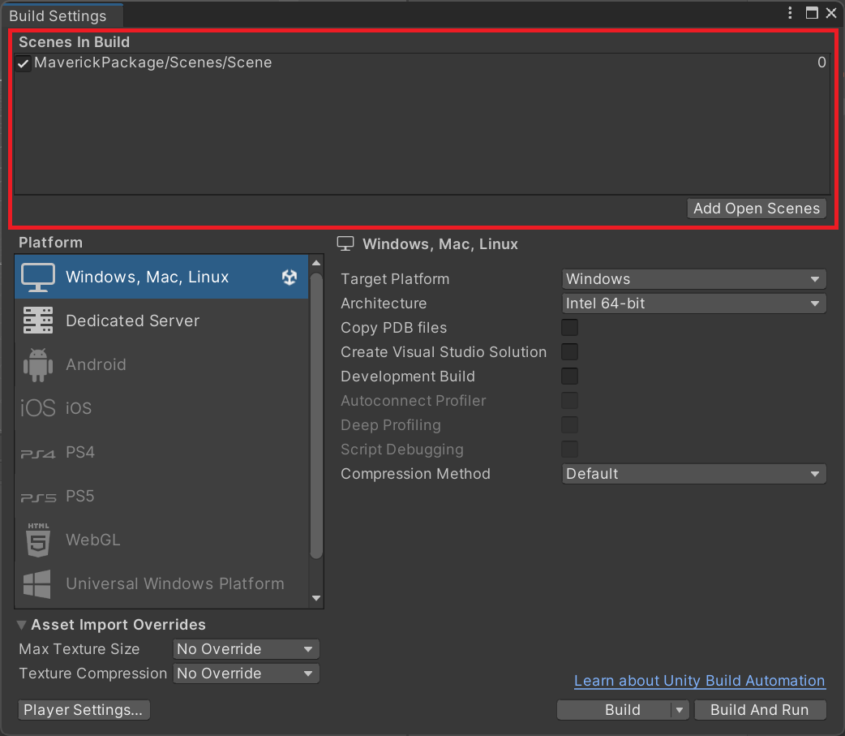

2. Install maverick.pack.tool : just click on following menu item  
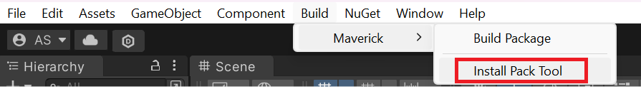

In case if you had install it earlier – you will see error in console like:  
*Process error: Tool 'maverick.pack.tool' is already installed*.  
Don’t be afraid – it’s normal.

**Build maverick package**

1. Increase version in package data scriptable object:  
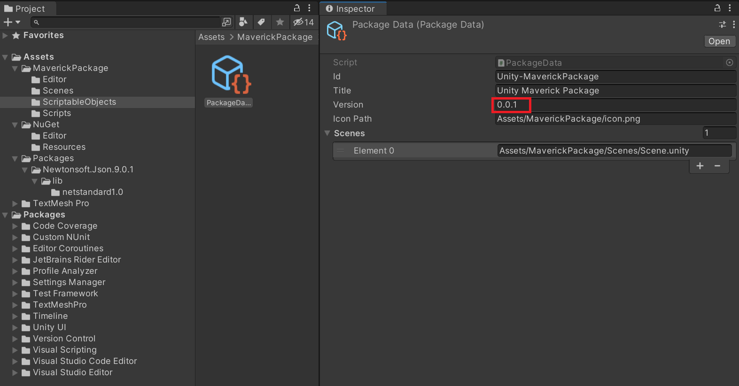

2. Run build process: just click on following menu item  
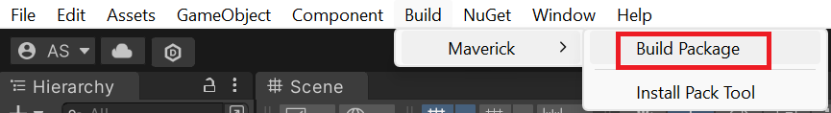

3. When build process will be finished - you will be redirected in file explorer

where folder:

Builds – contain prepared maverick package to upload in <https://cx-log-api-dev.azurewebsites.net/Packages>

Source – usual unity app build